INCLUDEPICTURE "../../../73B5~1/AppData/Local/Temp/FineReader10/media/image1.jpeg" \* MERGEFORMAT 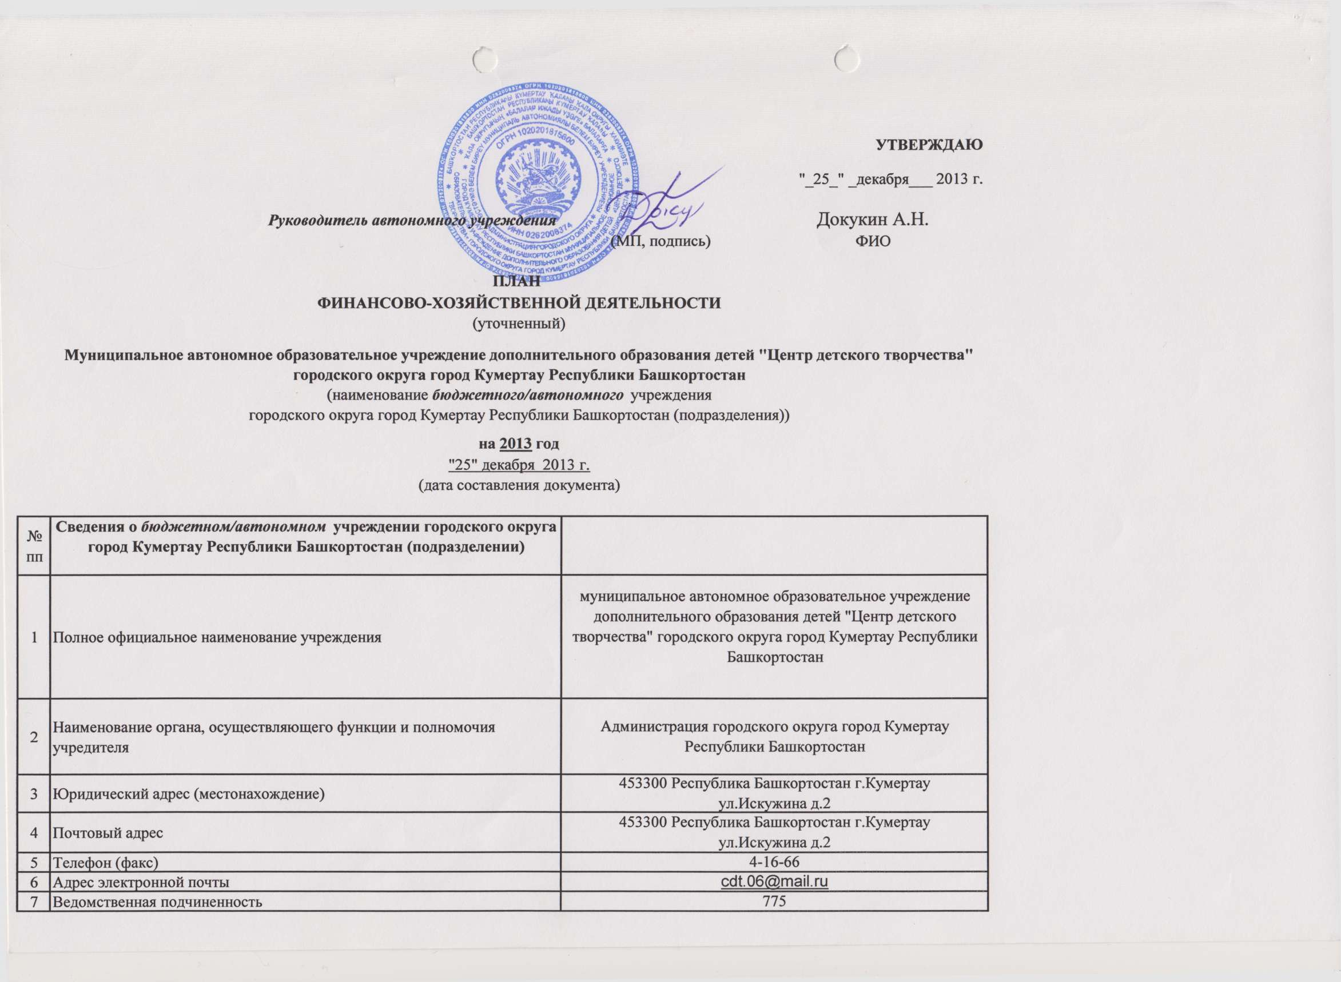
INCLUDEPICTURE "../../../73B5~1/AppData/Local/Temp/FineReader10/media/image2.jpeg" \* MERGEFORMAT 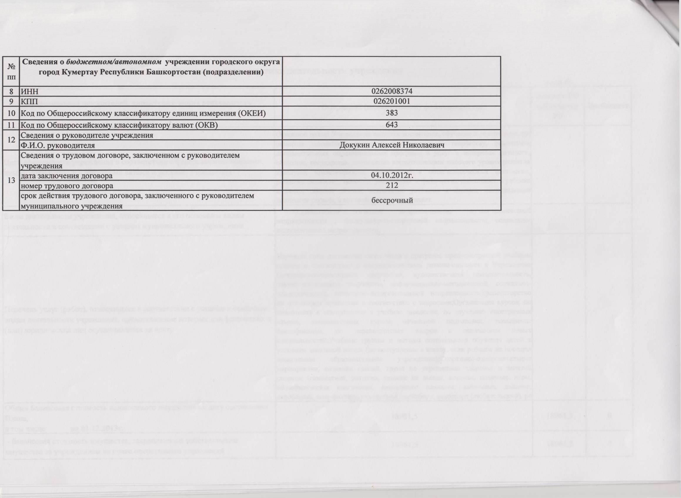
INCLUDEPICTURE "../../../73B5~1/AppData/Local/Temp/FineReader10/media/image3.jpeg" \* MERGEFORMAT 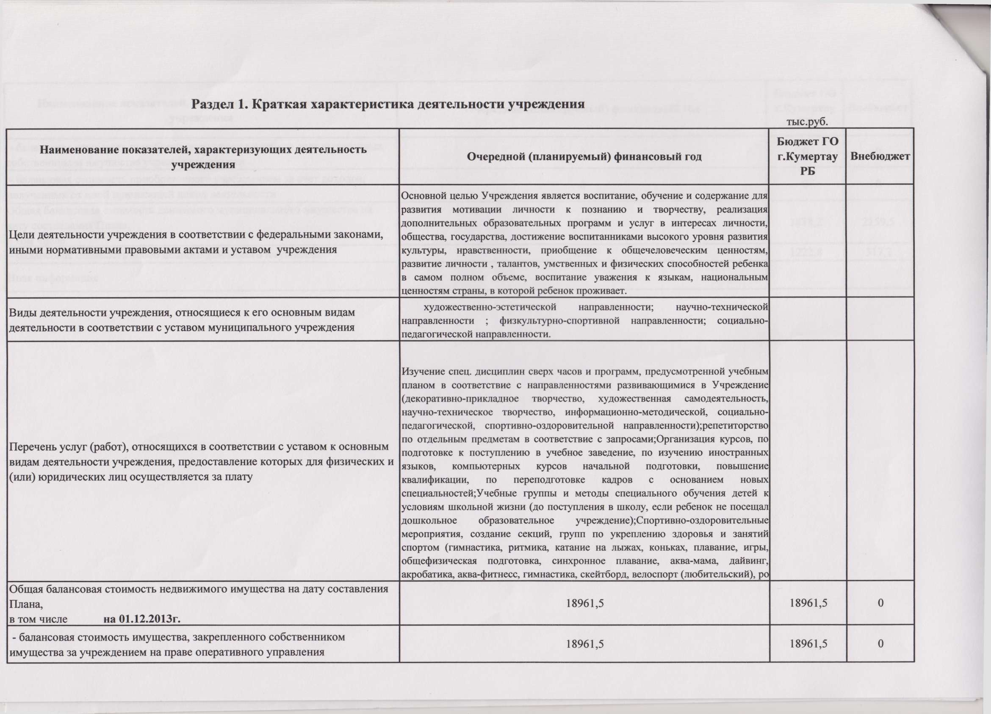
INCLUDEPICTURE "../../../73B5~1/AppData/Local/Temp/FineReader10/media/image4.jpeg" \* MERGEFORMAT 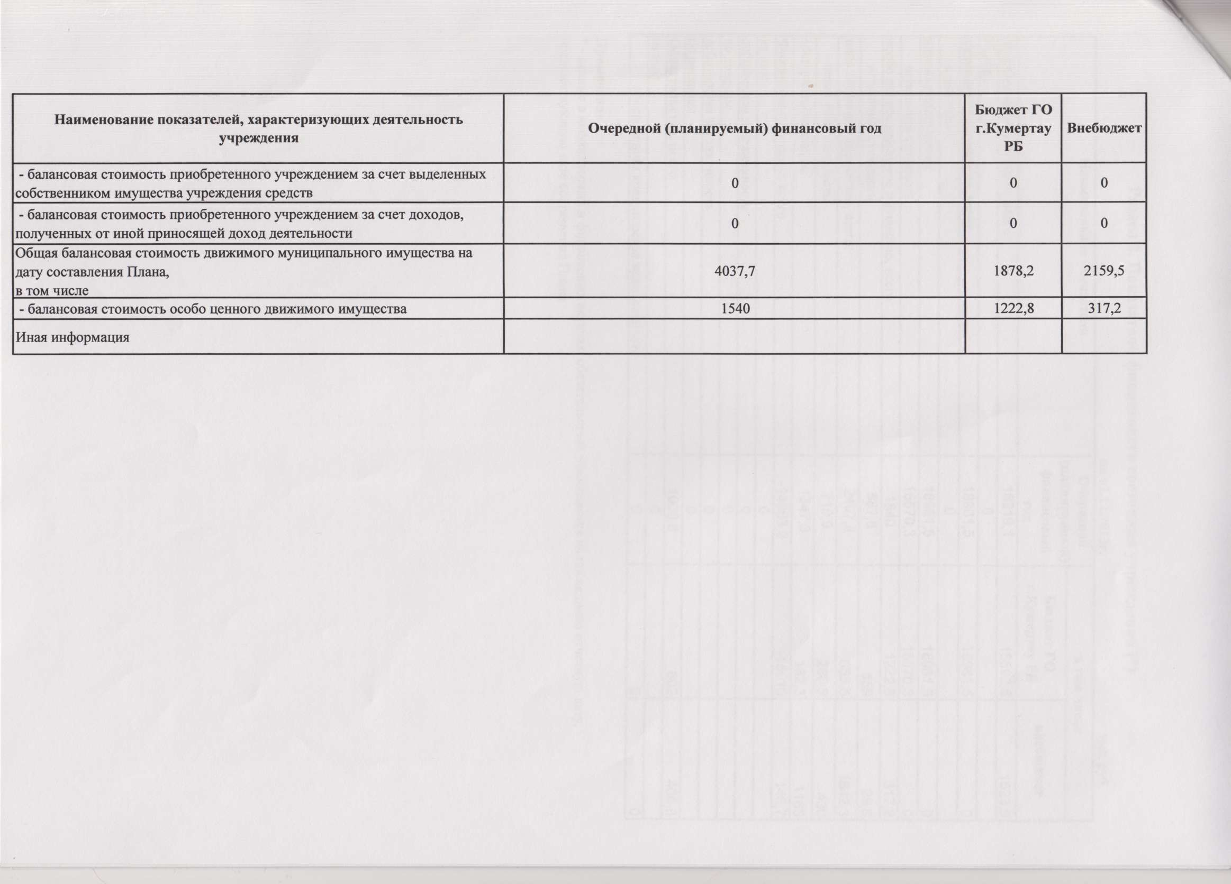
INCLUDEPICTURE "../../../73B5~1/AppData/Local/Temp/FineReader10/media/image5.jpeg" \* MERGEFORMAT 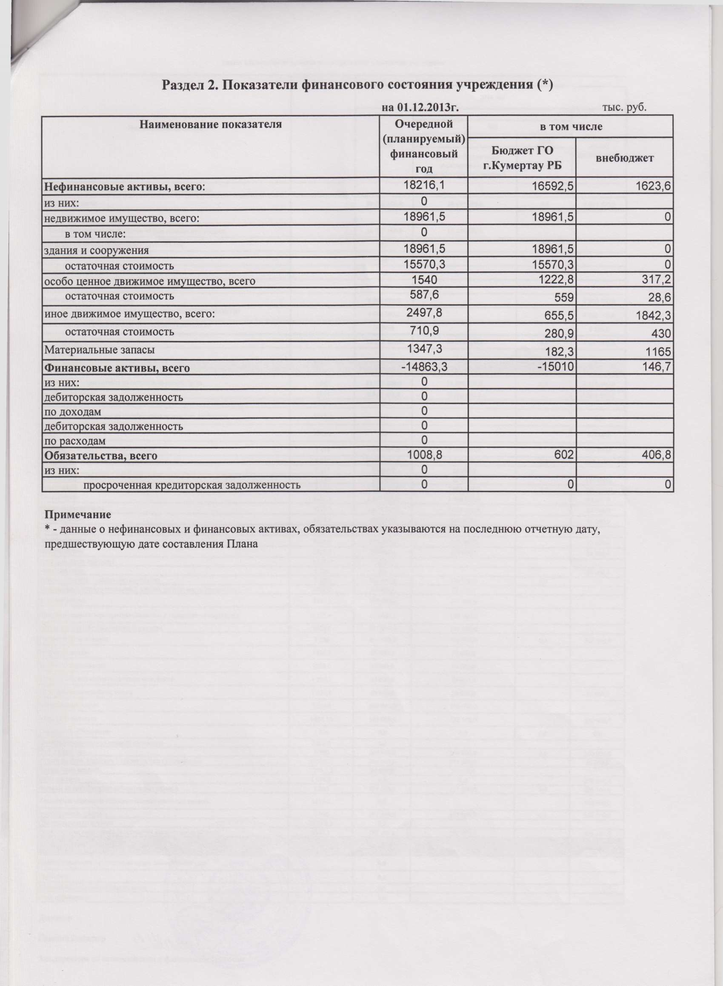
INCLUDEPICTURE "../../../73B5~1/AppData/Local/Temp/FineReader10/media/image6.jpeg" \* MERGEFORMAT 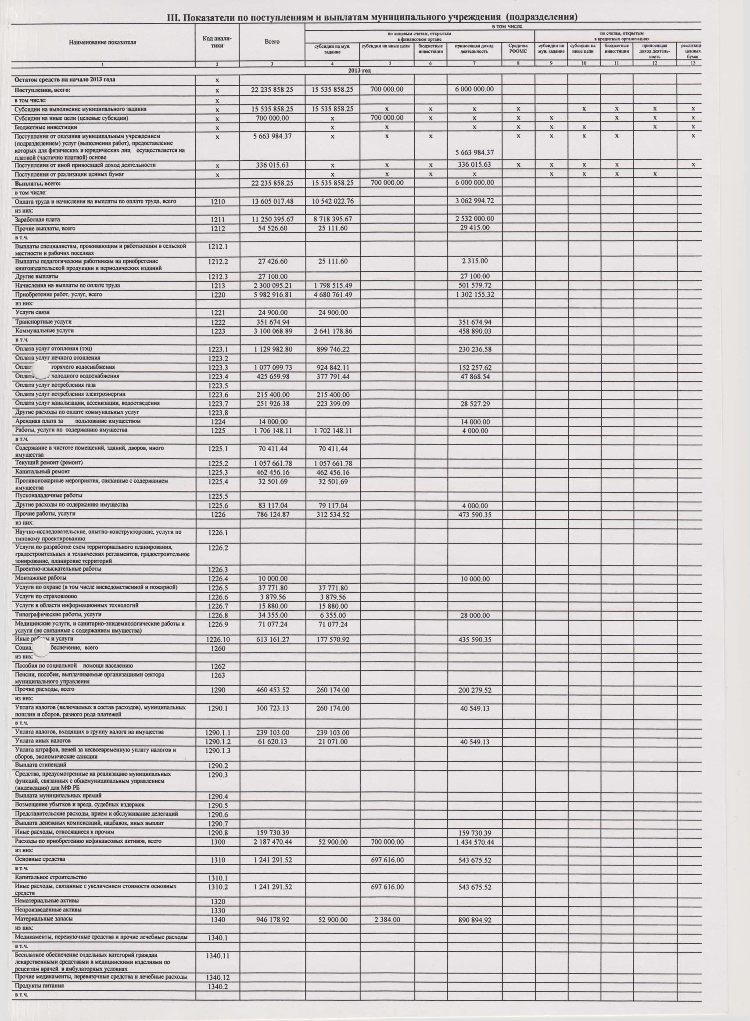
INCLUDEPICTURE "../../../73B5~1/AppData/Local/Temp/FineReader10/media/image7.jpeg" \* MERGEFORMAT 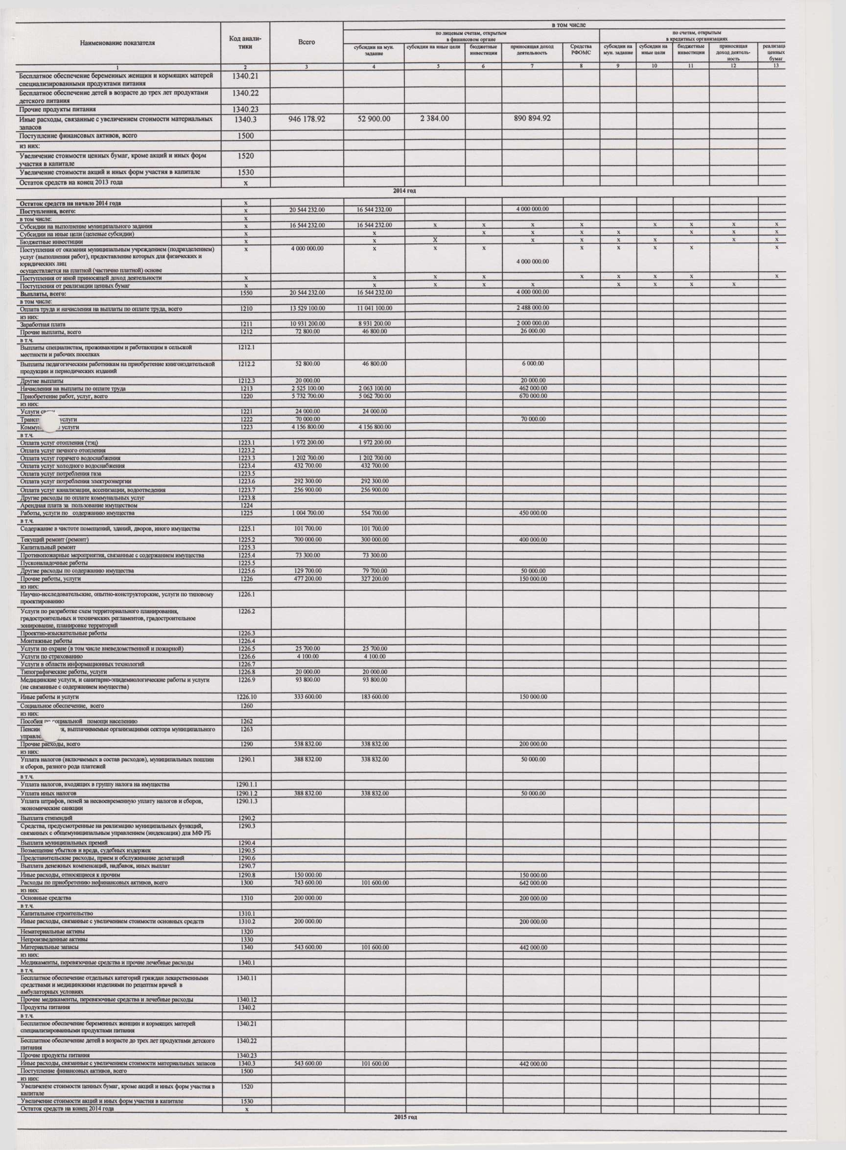
INCLUDEPICTURE "../../../73B5~1/AppData/Local/Temp/FineReader10/media/image8.jpeg" \* MERGEFORMAT 